From: https://www.technologyreview.com/s/614572/political-war-memes-disinformation/
Keywords: Half-truths, meme war, trading up the chain, amplification,
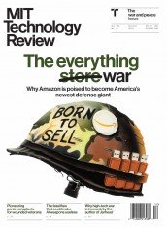

This story is part of our November/December 2019 issue
See the rest of the issue
Subscribe

How memes got weaponized: A short history

Memes come off as a joke, but some people are starting to see them as the serious threat they are.
by Joan Donovan
Oct 24, 2019
In October 2016, a friend of mine learned that one of his wedding photos had made its way into a post on a right-wing message board. The picture had been doctored to look like an ad for Hillary Clinton’s campaign, and appeared to endorse the idea of drafting women into the military. A mutual friend of ours found the image first and sent him a message: “Ummm, I saw this on Reddit, did you make this?”
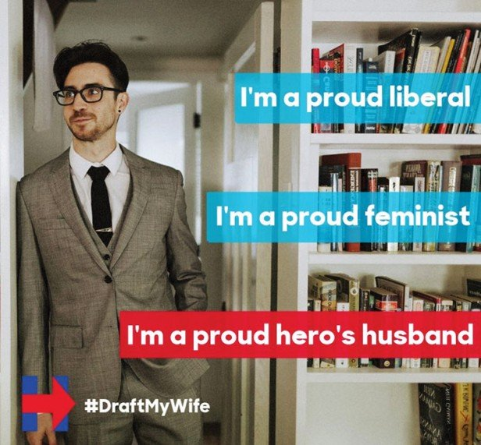
This was the first my friend had heard of it. He hadn’t agreed to the use of his image, which was apparently taken from his online wedding album. But he also felt there was nothing he could do to stop it.
So rather than poke the trolls by complaining, he ignored it and went on with his life. Most of his friends had a laugh at the fake ad, but I saw a huge problem. As a researcher of media manipulation and disinformation, I understood right away that my friend had become cannon fodder in a “meme war”—the use of slogans, images, and video on social media for political purposes, often employing disinformation and half-truths.
While today we tend to think of memes as funny images online, Richard Dawkins coined the term back in 1976 in his book The Selfish Gene, where he described how culture is transmitted through generations. In his definition, memes are “units of culture” spread through the diffusion of ideas. Memes are particularly salient online because the internet crystallizes them as artifacts of communication and accelerates their distribution through subcultures.
Importantly, as memes are shared they shed the context of their creation, along with their authorship. Unmoored from the trappings of an author’s reputation or intention, they become the collective property of the culture. As such, memes take on a life of their own, and no one has to answer for transgressive or hateful ideas.
And while a lot of people think of memes as harmless entertainment—funny, snarky comments on current events—we’re far beyond that now. Meme wars are a consistent feature of our politics, and they’re not just being used by internet trolls or some bored kids in the basement, but by
- governments,
- political candidates, and
- activists
across the globe. Russia used memes and other social-media tricks to influence the US election in 2016, using a troll farm known as the Internet Research Agency to seed pro-Trump and anti-Clinton content across various online platforms.
Both sides in territorial conflicts like those between Hong Kong
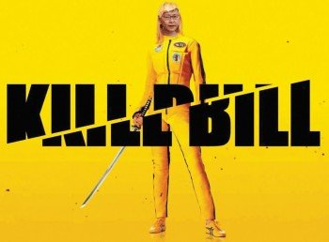
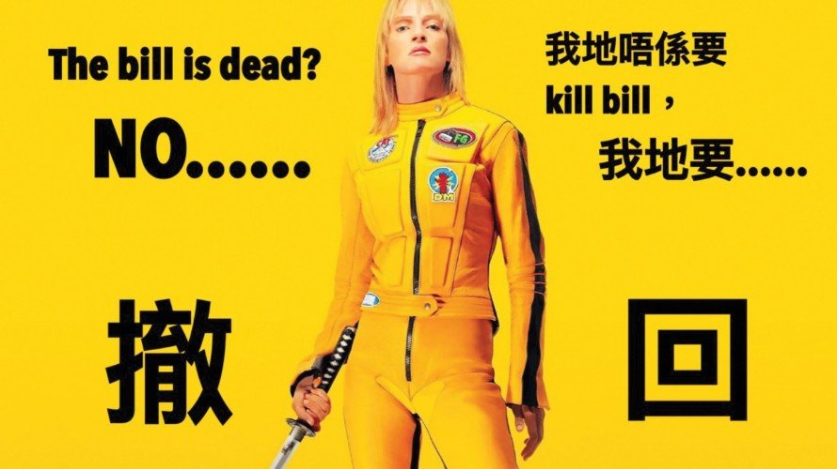
and China, Gaza and Israel, and India and Pakistan are using memes and viral propaganda to sway both local and international sentiment.
In 2007, for example, as he was campaigning for president, John McCain jokingly started to sing “Bomb bomb bomb, bomb bomb Iran” to the tune of the Beach Boys’ popular song “Barbara Ann.”
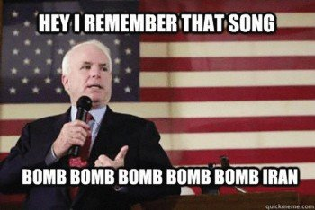
McCain, an Iran hawk, was talking up a possible war using the well-worn tactic of humor and familiarity: easy to dismiss as a joke, yet serving as a scary reminder of US military power. But it became a political liability for him. The slogan was picked up by civilian meme-makers, who spread and adapted it until it went viral. His opponent, Barack Obama, in essence got unpaid support from people who were better at creating persuasive content than his own campaign staff.
The viral success of memes has led governments to try imitating the genre in their propaganda. These campaigns are often aimed at the young, like the US Army’s social-media-focused “Warriors Wanted” program, or the British Army campaign that borrows the visual language of century-old recruiting posters to make fun of millennial stereotypes.
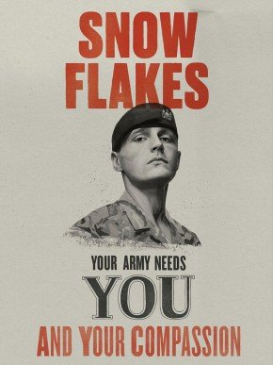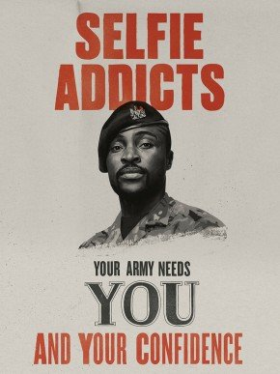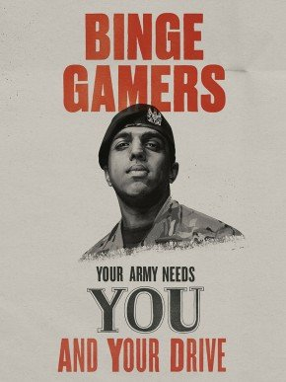
These drew ridicule when they were launched earlier this year, but they did boost recruitment.
However, using memes this way misses the point entirely. As mentioned, great memes are authorless. They move about the culture without attribution.
Much more authentic military meme campaigns are coming from soldiers themselves, such as the memes referencing the bungling idiot known simply as “Carl.” US service members and veterans run websites that host jokes and images detailing the reality of military life. Yet these serve a purpose not so different from that of official propaganda. They often feature heavily armed soldiers and serve to highlight, even in jokes, the tremendous destructive capacity of the armed forces. In turn, such memes have been turned into commercial marketing campaigns, such as one for the veteran-owned clothing company Valhalla Wear.
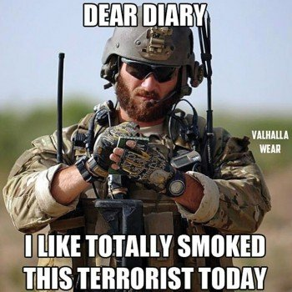

Recognizing this power of memes generated by ordinary people to serve a state’s [or an ordinary person's] propaganda narrative, in 2005 a Marine Corps major named Michael Prosser wrote a master’s thesis titled “Memetics—A Growth Industry in US Military Operations,” in which he called for the formation of a meme warfare center that would enroll people to produce and share memes as a way of swaying public opinion.
Prosser’s idea didn’t come to fruition, but the US government did come to recognize memetics as a threat. Beginning in 2011, the Defense Advanced Research Projects Agency offered $42 million in grants for research into what it called “social media in strategic communications,” with the hope that the government could detect “purposeful or deceptive messaging and misinformation” and create countermessaging to fight it.
Yet that research didn’t prepare DARPA for Russia’s 2016 disinformation campaign. Its extent was uncovered only by reporters and academics. That revealed a fatal flaw in national security: foreign agents are nearly impossible to detect when they hide within the civilian population. Unless social-media companies cooperate with the state to monitor attacks, this tactic remains in play.
My friend’s wedding photo provides a good illustration of how something as seemingly trivial as a meme can be turned into a powerful political weapon. In 2016, a Reddit message board, r/The_Donald, was a well-known meme factory for all things Trump. Imagery and sloganeering were beta-tested and refined there before being deployed by swarms of accounts on social-media platforms. Famous viral slogans launched from The_Donald included those having to do with “Pizzagate” and the Seth Rich murder conspiracy.
My friend’s picture was appropriated for a memetic warfare operation called #DraftMyWife or #DraftOurDaughters, which aimed to falsely associate Hillary Clinton with a revival of the draft. The strategy was simple: the perpetrators took imagery from Clinton’s official digital campaign materials, as well as pictures online like my friend’s, and altered them to make it look as if Clinton would draft women into the military if she became president. Someone who saw one of these fake campaign ads and then searched online would find that Clinton had in fact spoken in June 2016 in support of a bill that included a provision making women eligible to be drafted—but only in case of a national emergency. The bill was passed, but it was later changed to remove that requirement. This is what made #DraftMyWife sneaky—it was based on a kernel of truth.
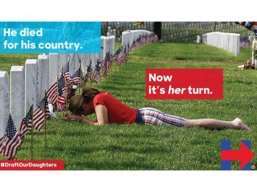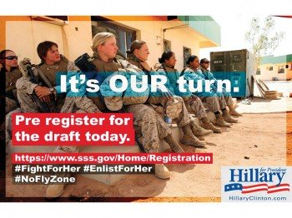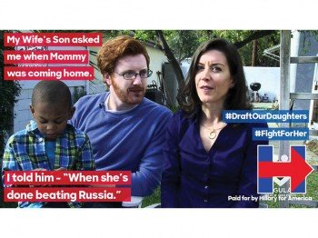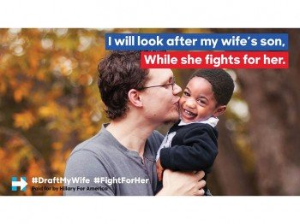
Memes like this often use a process called “trading up the chain,” pioneered by media entrepreneur Ryan Holiday, who describes the method in his book Trust Me, I’m Lying. Campaigns begin with posts in blogs or other news outlets with low standards. If all goes well, somebody notable will inadvertently spread the disinformation by tweet, which then leads to coverage in bigger and more reputable outlets. #DraftMyWife was outed fairly early on as a hoax and got debunked in the Washington Post, the Guardian, and elsewhere. The problem is, taking the trouble to correct disinformation campaigns like these can satisfy the goal of spreading the meme as far as possible—a process called amplification.
Memes online make hoaxes and psychological operations easy to pull off on an international scale. We should view them as a serious threat. The good news is that a bill in the works in the US Congress would form a national commission to assess the threat posed by foreign and domestic actors manipulating social media to cause harm.
Just focusing on those actors misses the point, though, for much the same reason those meme-inspired military recruiting campaigns missed the point. Memetic warfare works only if those waging it can rely on massive public participation to spread the memes and obscure their original authors. So rather than going after the meme creators, politicians and institutions looking to counter meme war might do better to strengthen the institutions that create and distribute reliable information—the media, academia, nonpartisan government agencies, and so on—while US cyber-defense works with the platform companies to root out influence operations.
And if that doesn’t work, blame Carl.
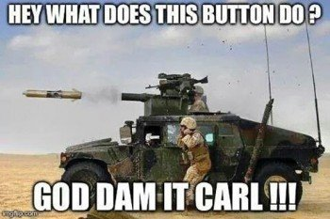

Joan Donovan leads the Technology and Social Change Research Project in the Shorenstein Center at the Harvard Kennedy School of Government.

There is much too much uncertainty on the effectiveness of what the Internet Research Agency accomplished for this unqualified assertion to stand, in a purportedly 'Technical' article. See, for lack of a more current and definitive article, https://taibbi.substack.com/p/russiagate-is-wmd-times-a-million/comments –FNC.

